1. Success message not display while create the record 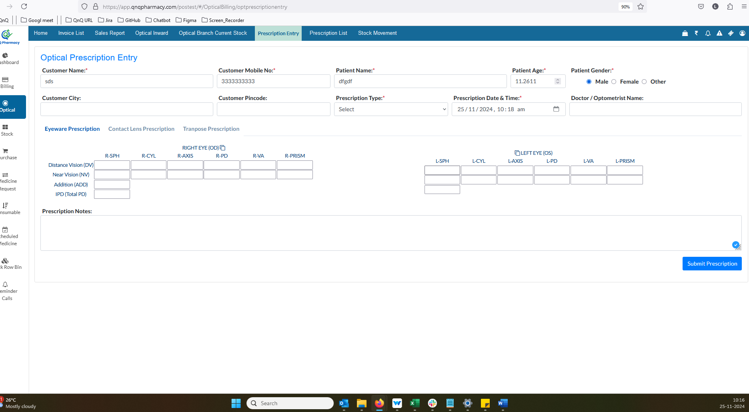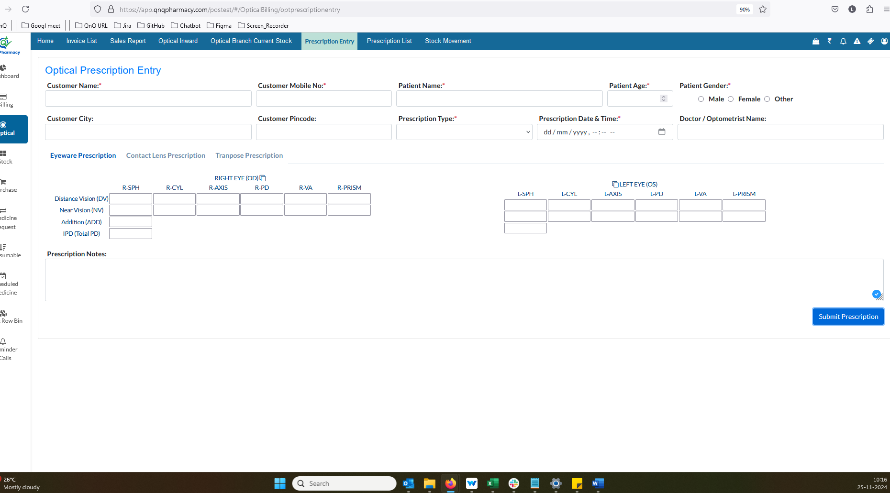//
2. Default Date and time value not display in Prescription Date & Time field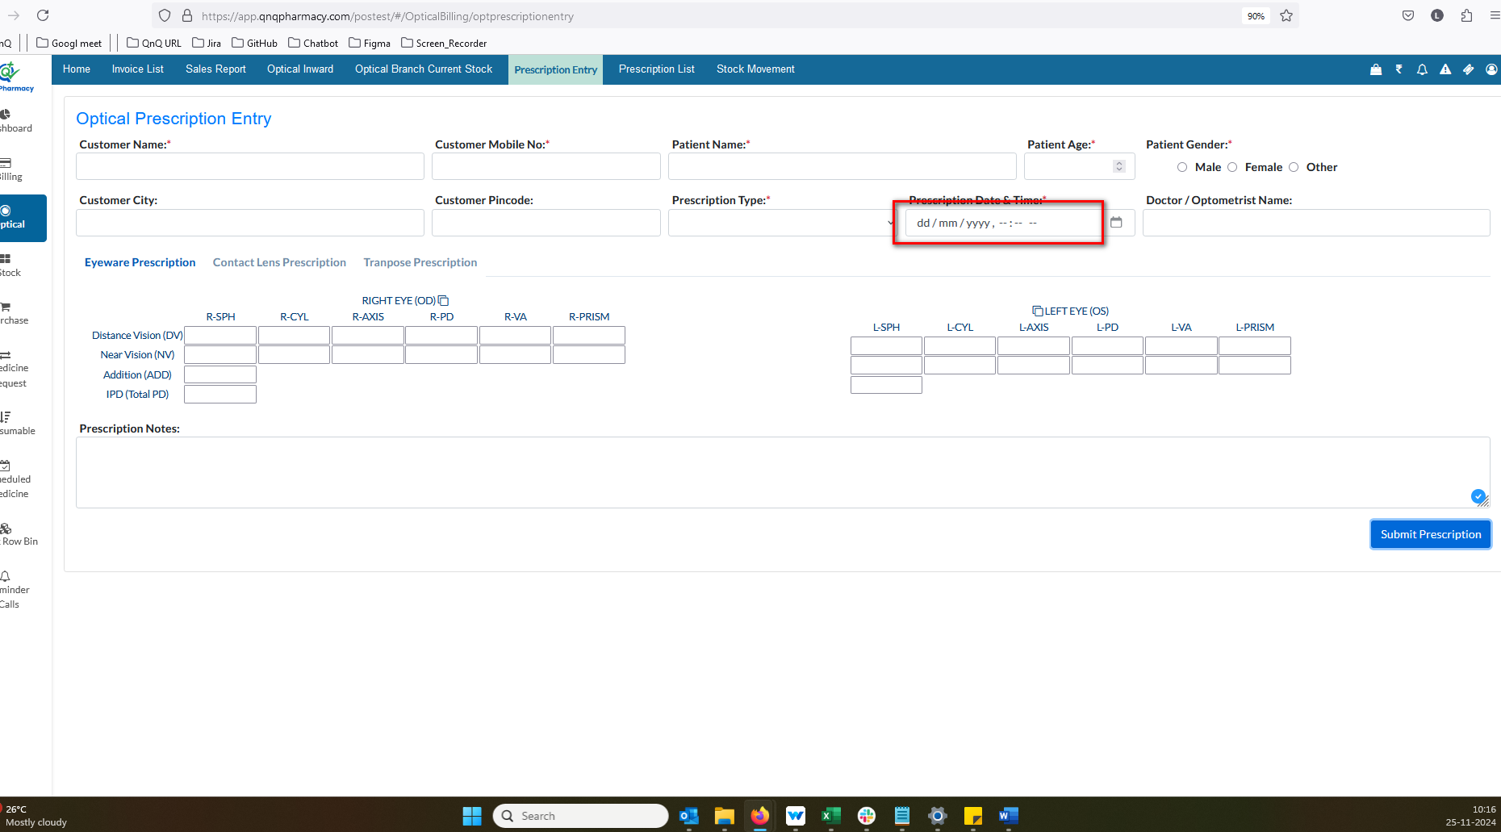/
3. Patient Gender value getting clear while create the record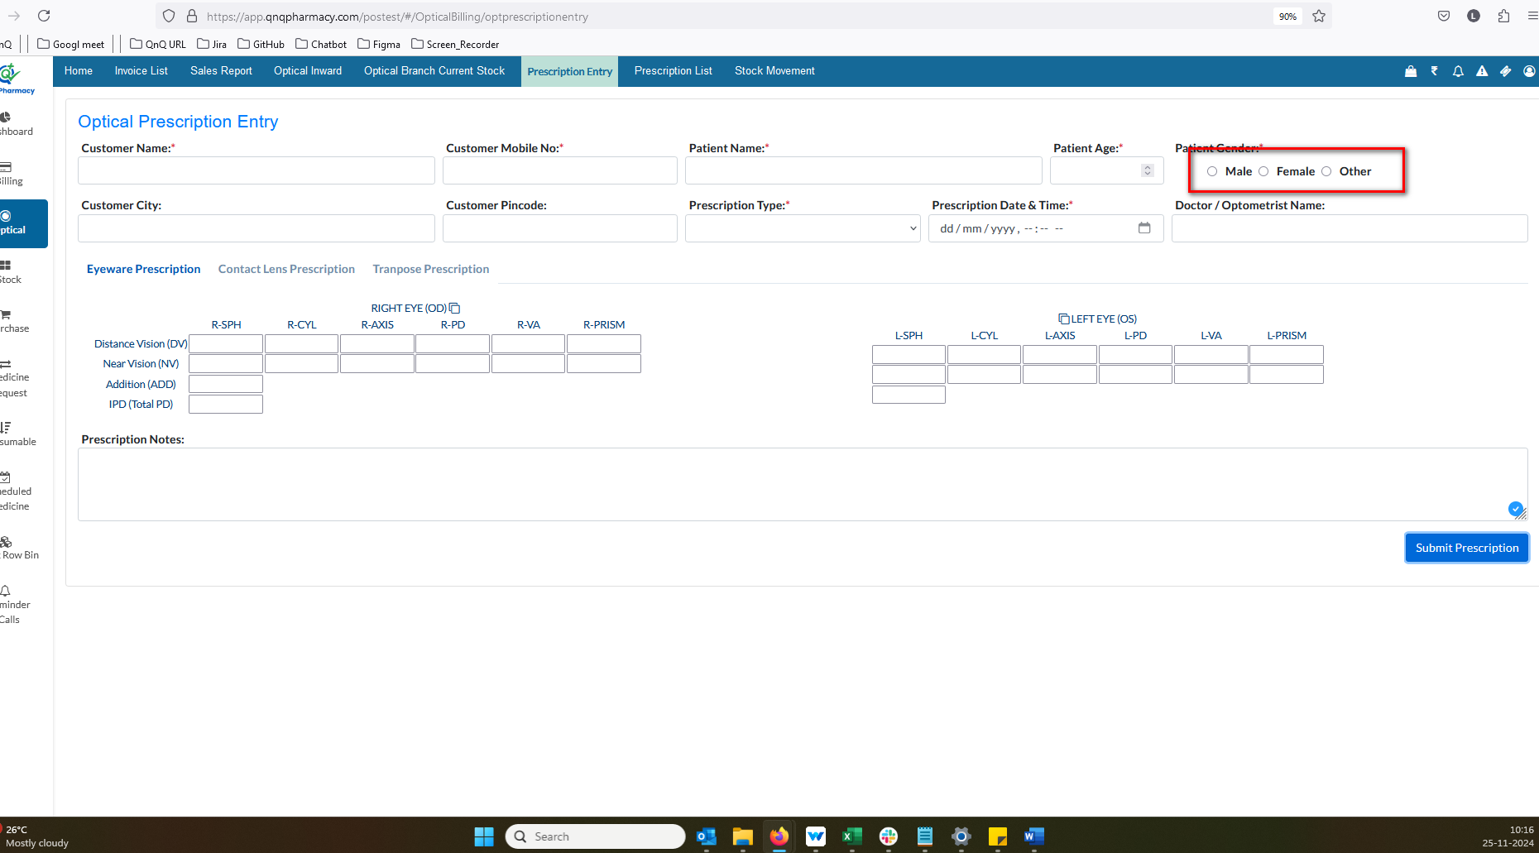//
4. Dot value not display short field label name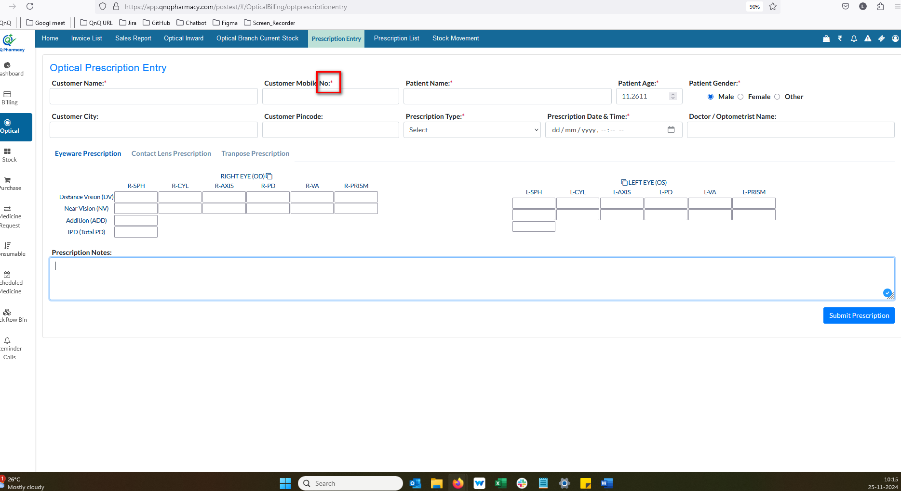//
5. Placeholder/Inner Text not display in any field 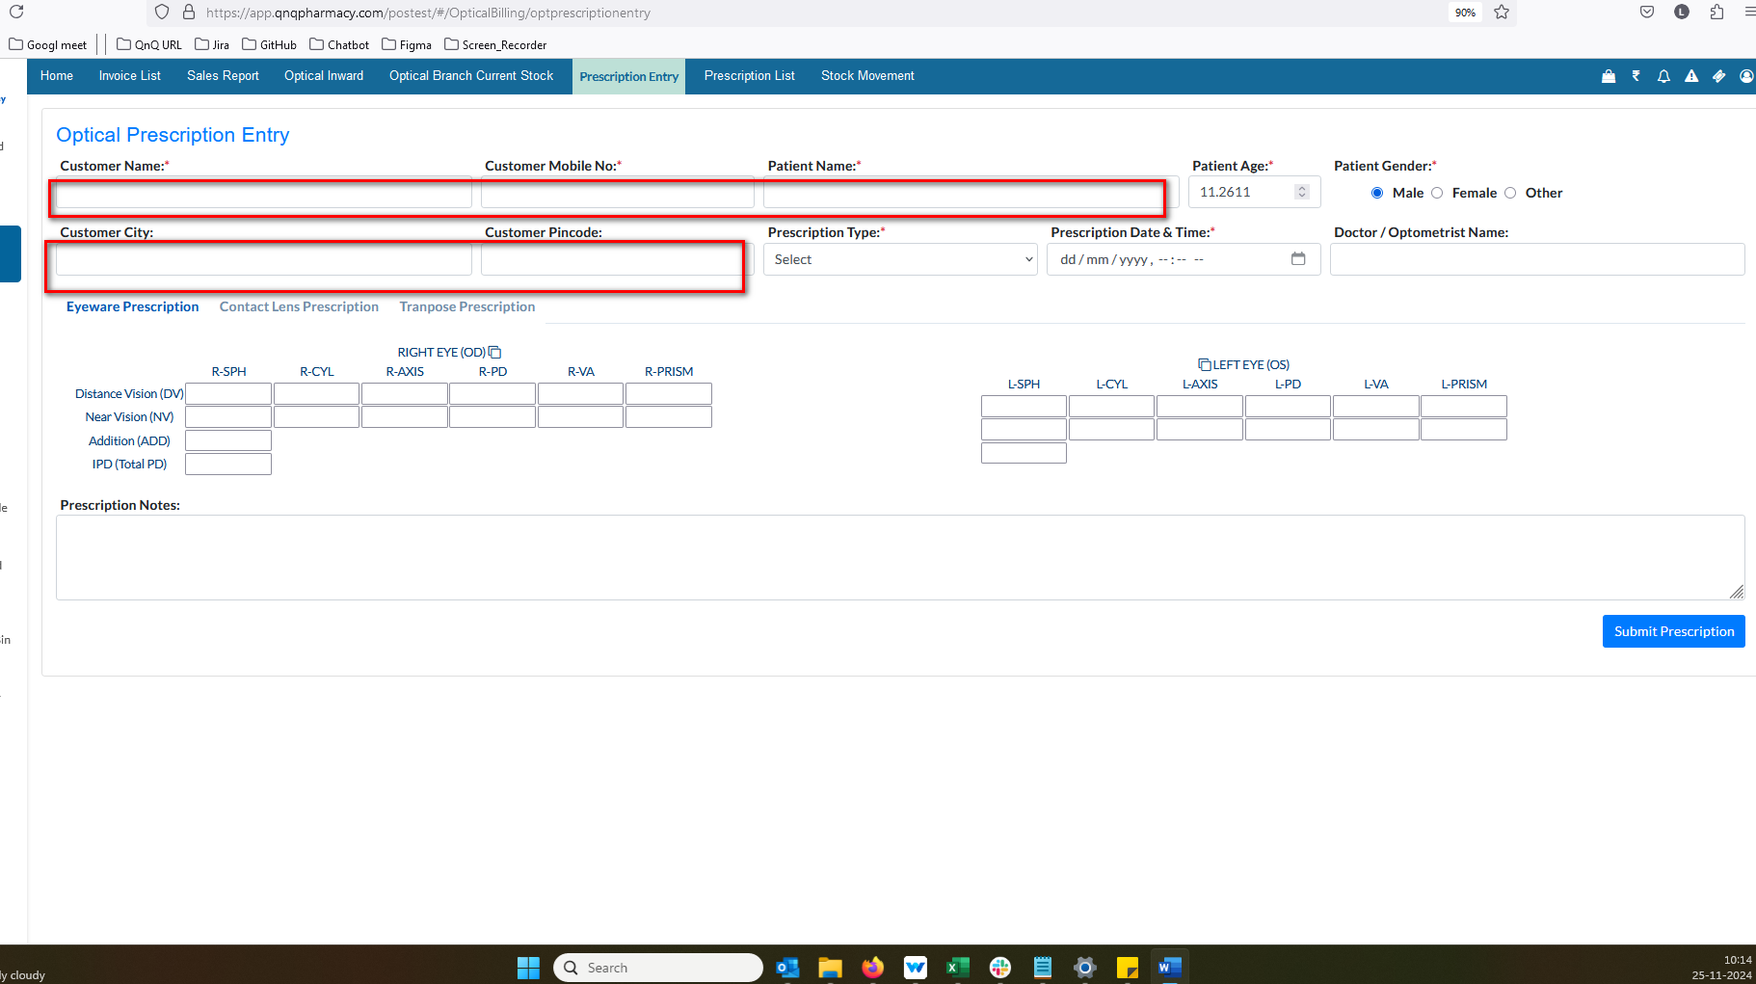//
6. Decimal value allows in Age. field 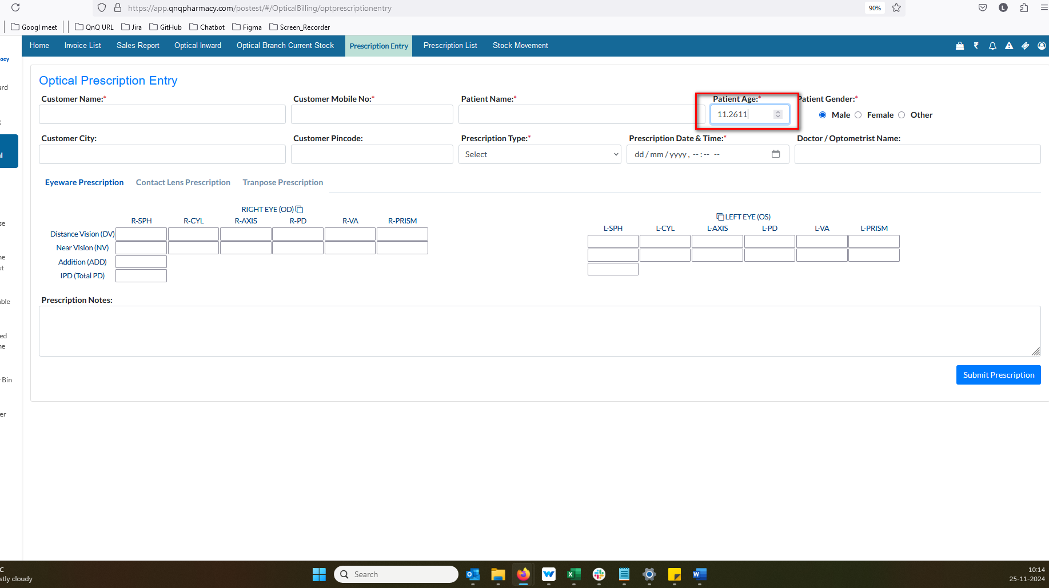//
7. Tab button’s display as normal label name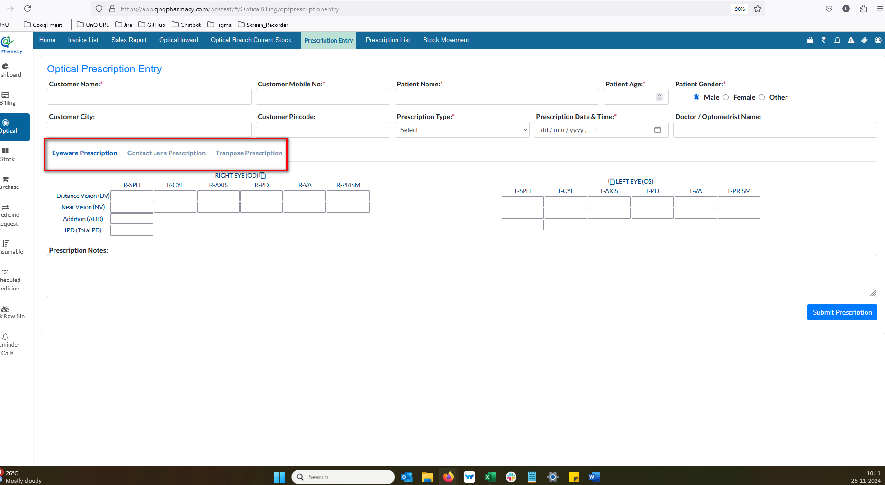//
8. Confirmation message not display in while navigate another screen with existing values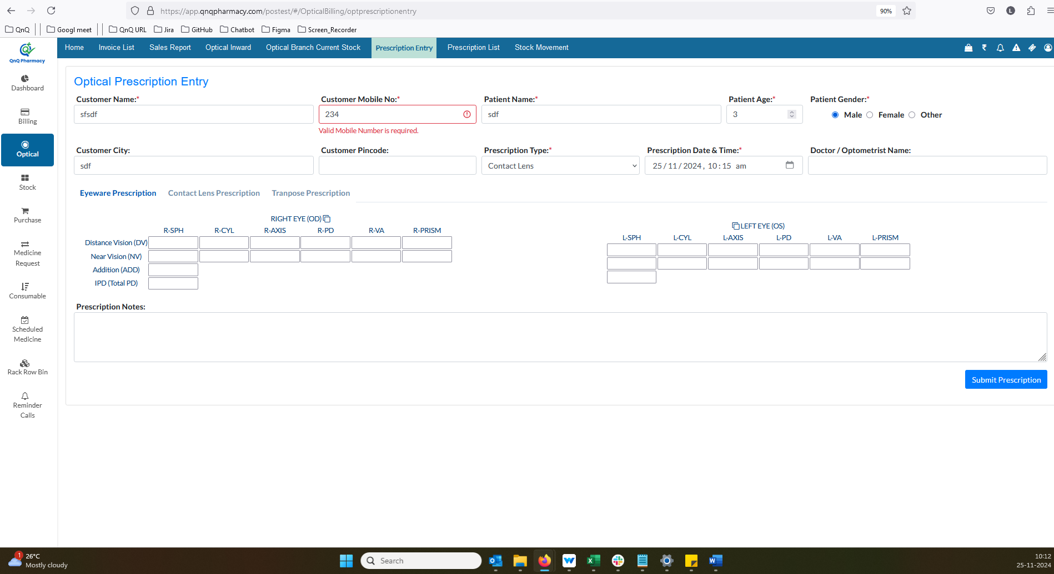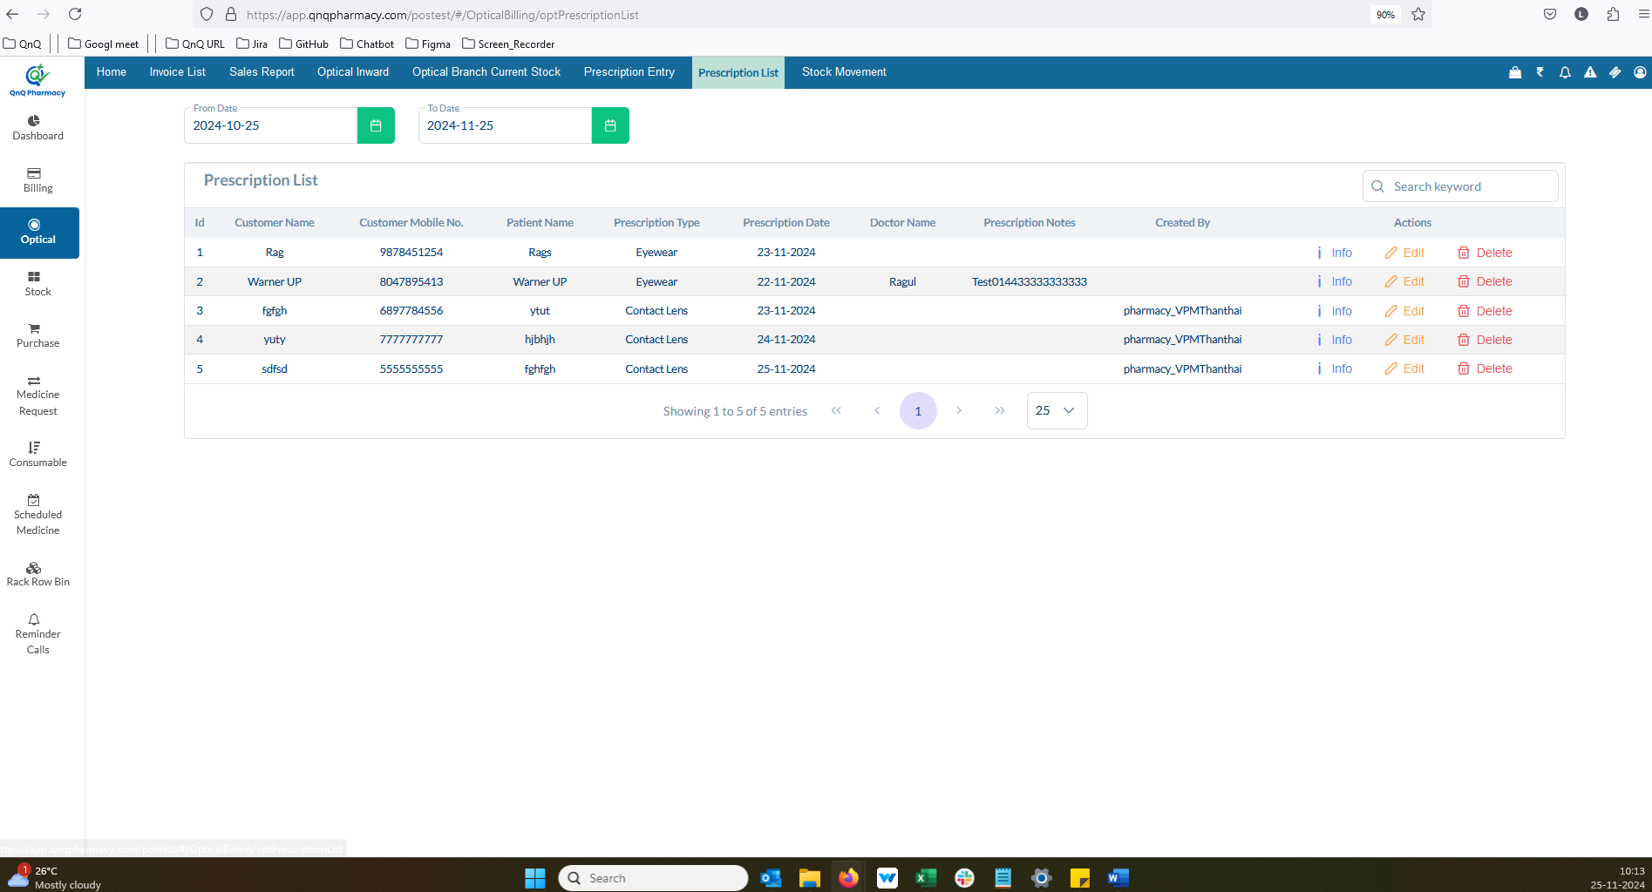//
9. The validation for the maximum character count is missing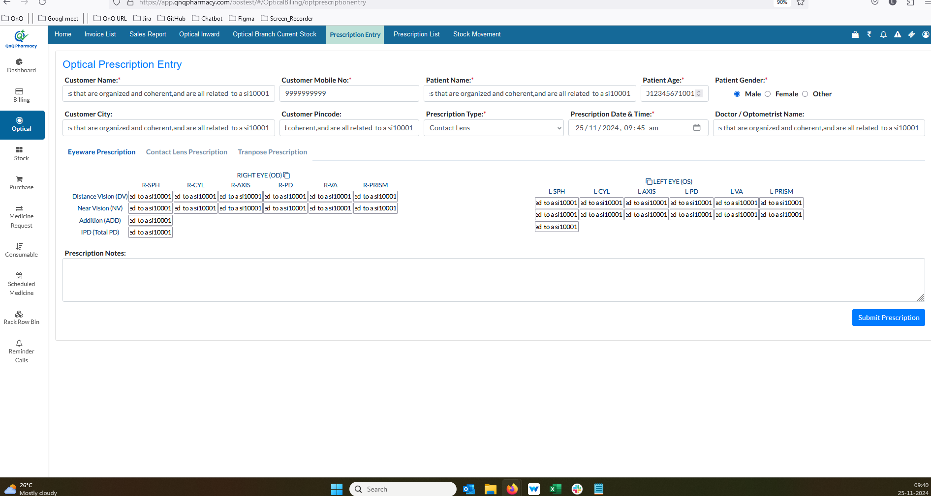//
10. Display the date field placeholder in lowercase letters 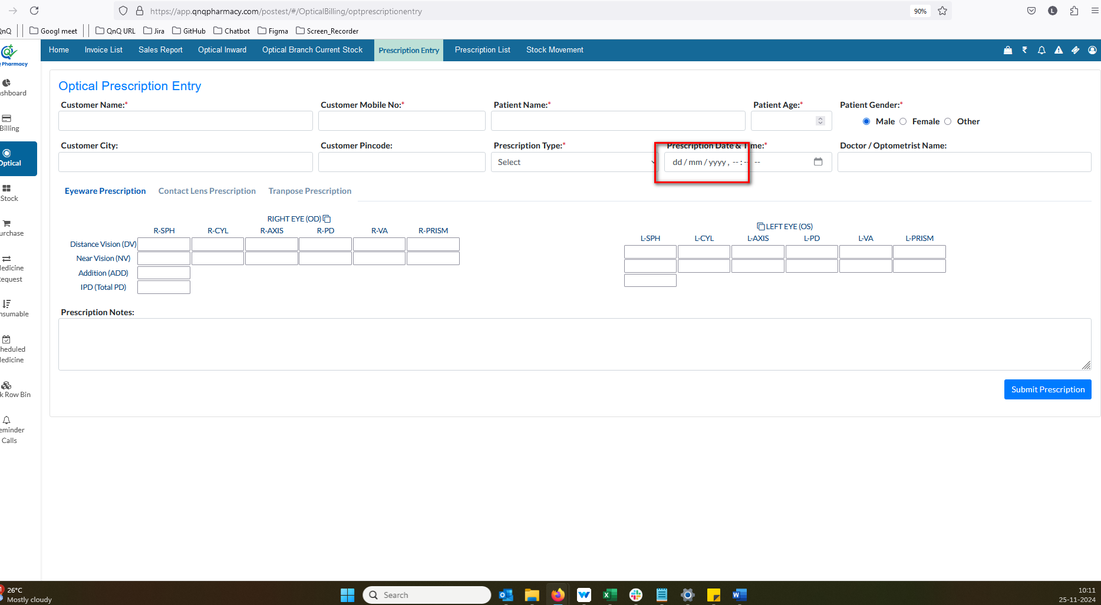//
11. //
12. //
13. //
14. //
15. //
16. //
17. //
18. //
19. //
20. //